**Interoception Worksheet 1**

*‘My heart is racing’*

*‘I have got butterflies in my stomach’*

*‘My shoulders feel tight’*

*‘I can feel it in my bones’*

Interoception is a process by which the nervous system senses bodily signals (e.g., hunger, temperature, pain and our heartbeat). This includes what is going on in our organs, muscles and bones. It is also referred to as our ‘sixth sense’ as it provides important information about how the outer world impacts our inner world and vice versa.

Some people are more aware of bodily sensations than others with some not noticing them at all. It can be easy to override them or overthink what they’re trying to tell us. How we make sense of what is happening in our body can in turn influence what is actually happening. Interpretation of body signals is key to which direction we will take. For example, we might want to avoid or get rid of the feeling.

Making Friends with Uncertainty relies us to sit with the sensations, rather than trying to avoid them. Learning how we experience uncertainty, through interoception, is an important first step of getting to know these bodily sensations and starting to sit with it.

Interoception is related to both our physical and emotional needs and drives behaviour. It is an important part of how we experience emotion. Our body is trying its best to keep us on a level and signal what we may need at any given moment in any situation. This can include the sense of ‘fight or flight’ where out body senses we feel threatened and is reacting to try and get us to ‘safety’. This threat could be uncertainty and the resulting feelings and sensations is how our body tries to respond.

The below activity will help us begin using interoception and begin to recognise how these sensations feel to us:

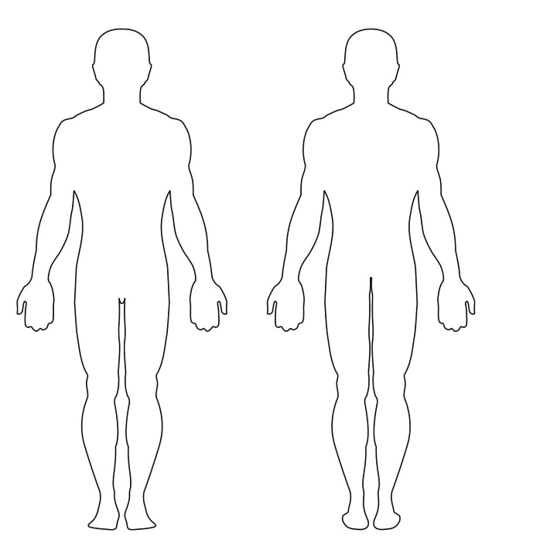

*Front Back*

1. Can you think of an uncertainty you’re experiencing currently?
2. Using the body map to the left can you locate the feeling? Where is it? Please draw or mark this on the image to the left.
3. Can you draw the feeling on the body map? What does it look like?
4. Can you describe what this feeling is like for you? Heavy? Tight? Loose?